**Project Planning Phase**

**Project Planning Template (Product Backlog, Sprint Planning, Stories, Story points)**

|  |  |
| --- | --- |
| Date | 07 November 2022 |
| Team ID | PNT2022TMID43705 |
| Project Name | Project -Airlines data analytics for avaition industry |
| Maximum Marks | 8 Marks |

**Product Backlog, Sprint Schedule, and Estimation (4 Marks)**

Use the below template to create product backlog and sprint schedule

|  |  |  |  |  |  |  |
| --- | --- | --- | --- | --- | --- | --- |
| **Sprint** | **Functional**  **Requirement (Epic)** | **User**  **Story**  **Number** | **User Story / Task** | **Story Points** | **Priority** | **Team Members** |
| Sprint1 | Registration | USN-1 | As a user, I can register for the application by entering my email, password, and confirming my password. | 4 | High | DHIFANI  STENIKSHA  D |
| Sprint1 | Login | USN-2 | As a user, I adapt to logging into the system with credentia | 2 | Low | BARATH |
| Sprint1 | Designation of Region | USN-3 | As a user, I can collect the dataset and select the region  of interest to be monitored and analysed | 2 | Low | GOKUL RAJ |
| Sprint2 | Exploration Of The Data | USN-4 | As a developer,I will explore the given dataset through cognos. | 3 | Medium | BHUVANESH |
| Sprint2 | Visualization Of The Dataset | USN-5 | As a developer,I will visualize the given dataset into a dashboard using cognos | 2 | Low | DHIFANI  STENIKSHA  D |
| Sprint3 | Customization  Of The  Dashboard | USN-6 | As a user,I can customize the visualized dashboard. | 2 | Low | BARATH |
| Sprint3 | Ease of Access | USN-7 | As a user,I can easily access and | 2 | Low | GOKULRAJ |
| **Sprint** | **Functional**  **Requirement (Epic)** | **User**  **Story**  **Number** | **User Story / Task** | **Story Points** | **Priority** | **Team Members** |
|  |  |  | manipulate the dashboard. |  |  |  |
| Sprint4 | Report  Generation | USN-8 | As a user,I can view the detailed report of my visualization. | 4 | High | DHIFANI  STENIKSHA D |
| Sprint4 | Establishment of the  Dashboard | USN-9 | As a developer,I established the dashboard intoa website and submit the website. | 3 | Medium | BHUVANESH |

**Project Tracker, Velocity & Burndown Chart: (4 Marks)**

|  |  |  |  |  |  |  |
| --- | --- | --- | --- | --- | --- | --- |
| **Sprint** | **Total**  **Story**  **Points** | **Duration** | **Sprint**  **Start**  **Date** | **Sprint End**  **Date**  **(Planned)** | **Story Points**  **Completed (as on**  **Planned End Date)** | **Sprint**  **Release Date**  **(Actual)** |
| Sprint1 | 20 | 6 Days | 24 Oct  2022 | 29 Oct 2022 | 12 | 29 Oct 2022 |
| Sprint2 | 20 | 6 Days | 31 Oct  2022 | 05 Nov 2022 | 12 | 05 Nov 2022 |
| Sprint3 | 20 | 6 Days | 07 Nov  2022 | 12 Nov 2022 | 12 | 12 Nov 2022 |
| Sprint4 | 20 | 6 Days | 14 Nov  2022 | 19 Nov 2022 | 12 | 19 Nov 2022 |

**Velocity:**

Imagine we have a 10-day sprint duration, and the velocity of the team is 20 (points per sprint). Let’s calculate the team’s average velocity (AV) per iteration unit (story points per day)

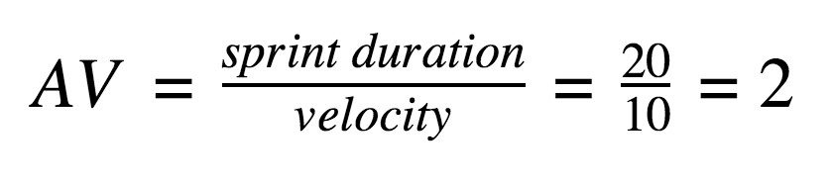

Average velocity=Sprint duration / velocity=12/6=2

**Burndown Chart:**

A burn down chart is a graphical representation of work left to do versus time. It is often used in agile [software development](https://www.visual-paradigm.com/scrum/what-is-agile-software-development/) methodologies such as [Scrum.](https://www.visual-paradigm.com/scrum/scrum-in-3-minutes/) However, burn down charts can be applied to any project containing measurable progress over time.

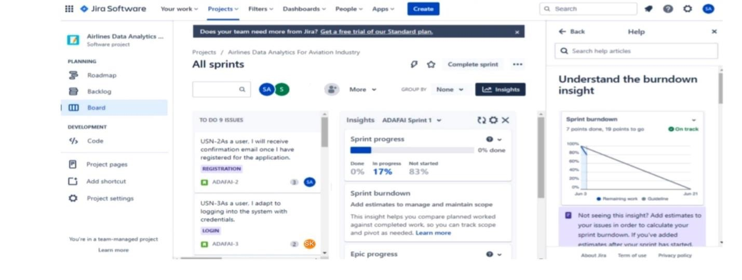

[**https://www.visual-paradigm.com/scrum/scrum-burndown-chart/**](https://www.visual-paradigm.com/scrum/scrum-burndown-chart/) [**https://www.atlassian.com/agile/tutorials/burndown-charts**](https://www.atlassian.com/agile/tutorials/burndown-charts)

**Reference:**

[**https://www.atlassian.com/agile/project-management**](https://www.atlassian.com/agile/project-management)

[**https://www.atlassian.com/agile/tutorials/how-to-do-scrum-with-jira-software**](https://www.atlassian.com/agile/tutorials/how-to-do-scrum-with-jira-software) [**https://www.atlassian.com/agile/tutorials/epics**](https://www.atlassian.com/agile/tutorials/epics) [**https://www.atlassian.com/agile/tutorials/sprints**](https://www.atlassian.com/agile/tutorials/sprints)

[**https://www.atlassian.com/agile/project-management/estimation**](https://www.atlassian.com/agile/project-management/estimation) [**https://www.atlassian.com/agile/tutorials/burndown-charts**](https://www.atlassian.com/agile/tutorials/burndown-charts)